**Nama : Zabania Az Zahra Kusumayuri**

**NIM : 071911633014**

**Tugas Individu 1**

* Capture di Instagram

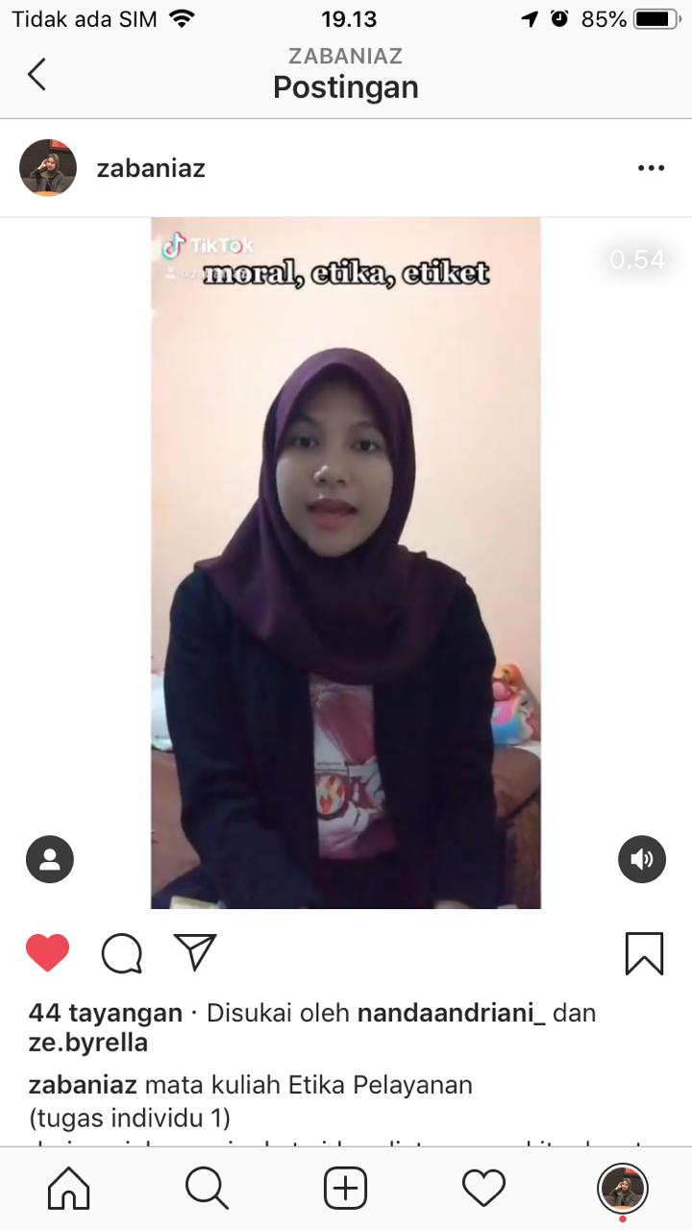

* Link video di TikTok

<https://vt.tiktok.com/ZS5aC9BG/>

* Link video di Instagram

<https://www.instagram.com/p/CE_nu0rhAwz/?igshid=1mdlwohgsdn49>